UID

**EXP.NO:3 230701217-NITHIN KUMAR K**

**1.CLI (Command Line Interface)**

For the **CLI**, you can provide a Python script that renames a file via command-line arguments. Here's how you could implement it:

**Python Code**

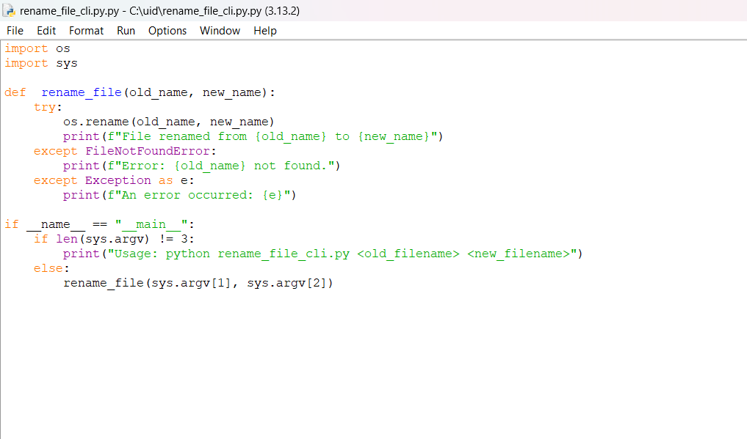

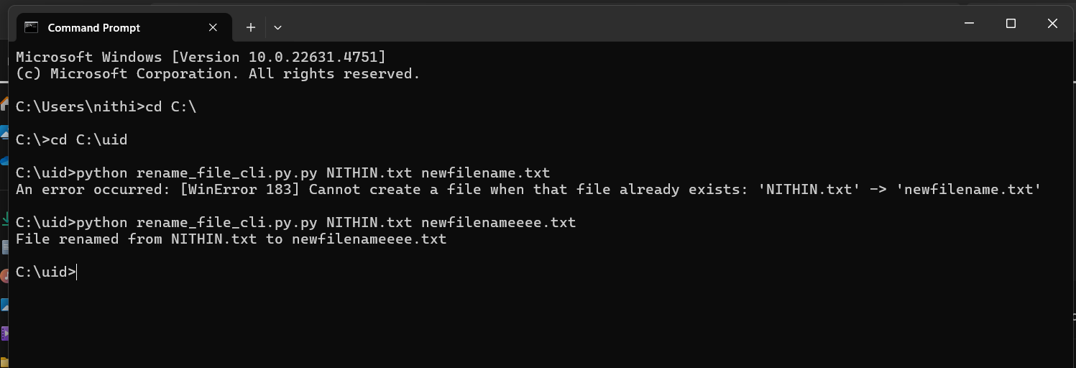

OUTPUT

**How it works**:  
The script accepts command-line arguments for the old and new filenames and renames the file.

**How It Works:**

1. **Imports:**
   * os for interacting with the file system.
   * sys for accessing command-line arguments.
2. **Function rename_file:**
   * Takes two arguments: old_name (current filename) and new_name (desired new filename).
   * Tries to rename the file using os.rename().
   * Handles FileNotFoundError if the original file doesn't exist.
   * Catches any other unexpected exceptions.

To use it:

python rename_file_cli.py oldfilename.txt newfilename.txt

**2.GUI (Graphical User Interface)**

In the **GUI**, we will use **Tkinter** to create a simple interface where the user can type the old and new filenames.

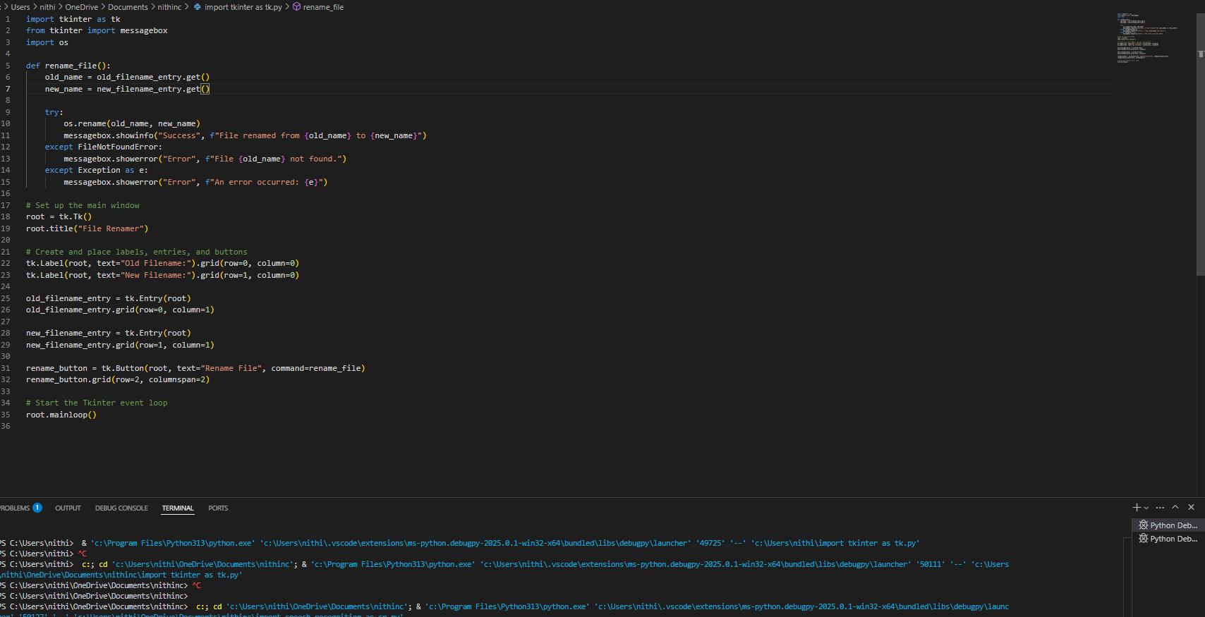

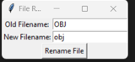

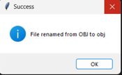

**How it works**:  
The GUI allows the user to input the old and new filenames, then click a "Rename File" button. Upon clicking the button, it attempts to rename the file and provides feedback via a message box.

**Visual Layout:**

* **Window Title:** *File Renamer*
* **Size:** 400x150 pixels (fixed, not resizable)

**\* Old Filename:**

*(Entry field aligned to the right with enough space to type file names)*

**\* New Filename:**

*(Another entry field right below the first one)*

**✅ Rename File Button:**

* **Color:** Green background with white text
* **Text:** *"Rename File"*
* **Centered below the input fields**

When you click the **Rename File** button:

* A pop-up will appear:
  + **Success Message:** Green tick icon with a confirmation.
  + **Error Message:** Red cross icon if there's an issue.
  + **Warning:** Yellow triangle if inputs are empty or overwriting a file.

3. **VUI (Voice User Interface)**

For the **VUI**, we can use the **SpeechRecognition** library to listen for voice commands. The user will say something like, "Rename oldfilename.txt to newfilename.txt."

